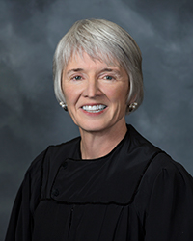

Honorable Patricia M. Lucas

The Honorable Patricia M. Lucas sits on the California Superior Court for Santa Clara County,
where she served as Presiding Judge 2017-18. She served for four years in the Family Division and was Supervising Judge of Family for over two years.

She currently handles a direct calendar of complex civil cases, and has presided over civil and criminal trials, a civil pretrial docket, and direct calendars in the Criminal Division. She has served as the Supervising Judge of the Civil Division, and in a pro tem assignment on the Sixth District Court of Appeal. Before Judge Lucas took office in 2003, she practiced complex civil litigation for over 20 years, most recently with the Silicon Valley firm of Fenwick & West, LLP where she chaired the Litigation Group.

Judge Lucas frequently teaches judges and served as the Dean of the California Judicial College. She has taught classes in Trials and in Civil Discovery to incoming California judges for many years. She also teaches lawyers through the National Institute for Trial Advocacy (NITA), and promotes education among the bench and bar through her participation on the boards of the William A. Ingram Inn of Court and the Association of Business Trial Lawyers.

Judge Lucas is a native of San Francisco, a graduate of University of California Berkeley School of Law, a citizen of the Republic of Ireland, and a mother and grandmother.

